|  |
| --- |
| CREATING NEW USERS |

Until now we’ve been logging in the system with the base credentials that Cobalt has provided – root. Under normal circumstances we would need more users in our system that just our dear root user so we will need to create new user accounts for those.

**CREATE A USER ‘PERSON’**

In Cobalt, new users require a ‘Person’ entry – this is where the user’s basic information is indicated such as the user’s name and gender. Navigate to the “Person” page, also located in the Admin sidebar.

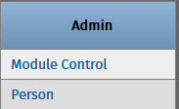

There is only one registered person in the system at the moment and that is the person associated with our root account – Super User X Root. 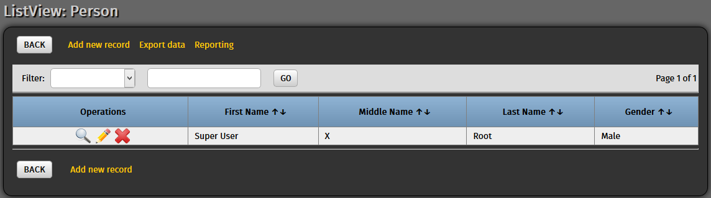

Click “Add new record” to start entering another person. Click “Submit” once you have entered the new person’s relevant information.

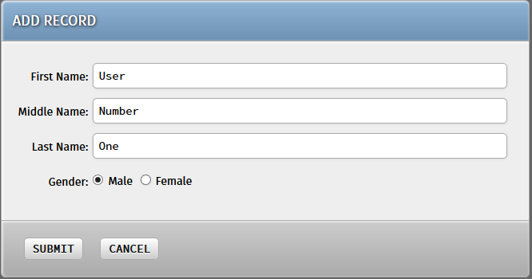

**CREATE THE USER**

Now that we have a person for our new user, we can start creating his user account. In the Admin sidebar once more, navigate to the “User” page.

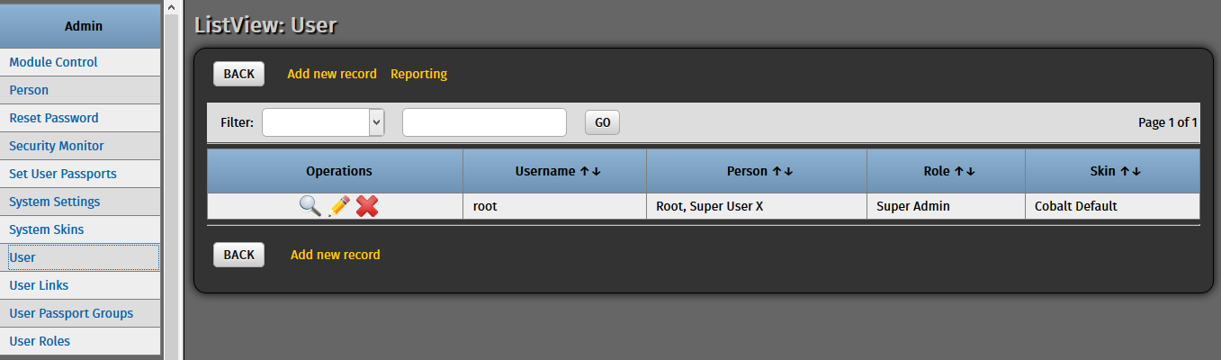

As expected, there is only one user in the system. Click “Add new record” to begin adding our new user.

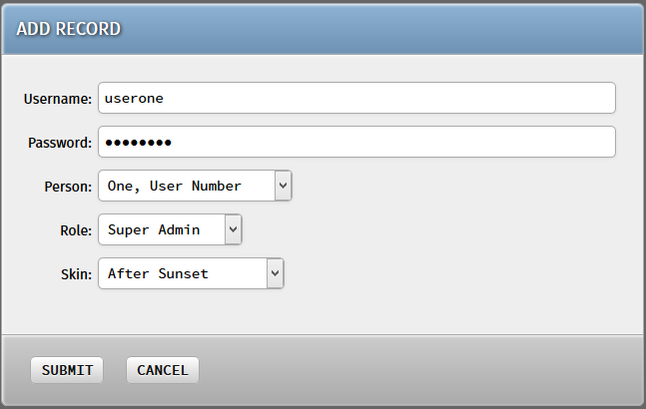

Provide a username and password then select the person entry we created earlier. For its roles, there are two available “Roles” in Cobalt which dictate the basic privileges that the new user is capable of doing.

* The *Super Admin* user is the privilege that our root user currently possesses. It has access to all the enabled modules of the system and the Admin modules as well.
* The *System Admin* user only has access to the Admin modules of the system. This is suited for administrators who only need to monitor the system and make configurations to it.

The “Skin” field is a cosmetic feature for Cobalt that decides the starting visual skin that the system will present to the user when he/she logs in. Hit “Submit” afterwards and our new user should be ready.

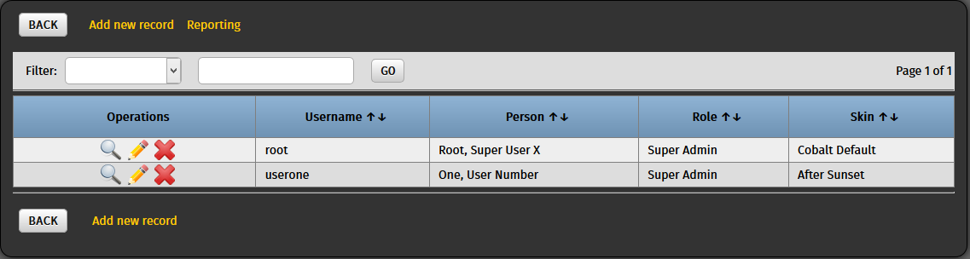

**LOG IN WITH THE NEW USER**

To try logging in with the new user, log out of the system first (or open a new private browser tab) and return to the system’s homepage.

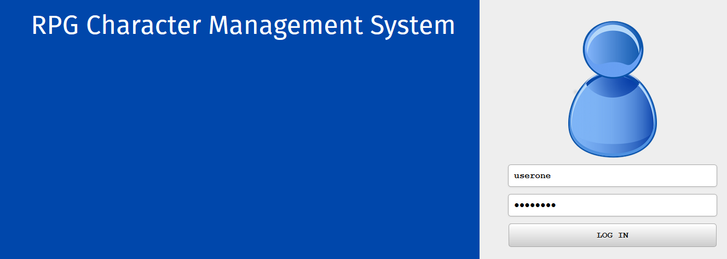

Provide your newly-created user’s credentials and click “Log In”. You should now see your new user in action!

